Create Node Red service

|  |  |
| --- | --- |
| Team ID | PNT2022TMID10261 |
| Project Name | Personal Assistant for senior people who are self reliant |

Step 1: Login into IBM CLOUD account

Step2: In catalog, search for node red application

Step 3: Enter the project details and click on create

Step 4: click on deploy option and deploy

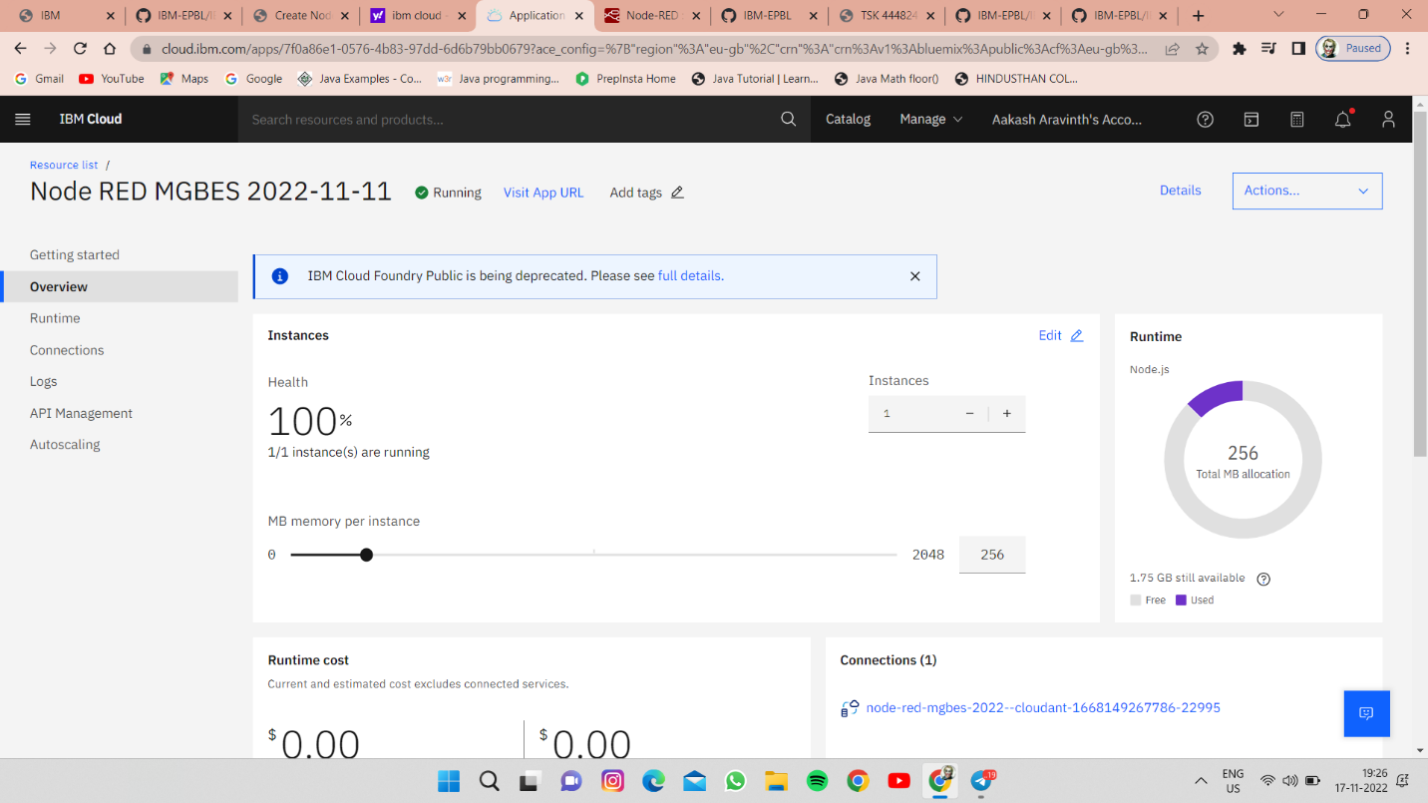

Step 5: Now drag and drop the nodes and connect nodes with IOT Watson platform

Step 6: Finally, output can be seen in node red service

